Warning to Teachers: This exam contains Static Electricity (Section B Q1) and refers to Resistivity (Section B Q4b) both are optional and may not have been taught

WACE 2BPHY: Physics EXAM

Question/Answer Booklet

Physics
Written paper
Please place your student identification label in this box
Stage 2B

Student Number: In figures

In words

Time allowed for this paper
Reading time before commencing work: Ten minutes
Working time for paper: Two and a half hours

Material required/recommended for this paper

To be provided by the supervisor
This Question/answer booklet; Formulae and constants sheet

To be provided by the candidate
Standard items: pens, pencils, eraser or correction fluid, ruler, highlighter
Special items: scientific calculator

Important note to candidates
No other items may be taken into the examination room. It is your responsibility to ensure that you do not have any unauthorised notes or other items of a non-personal nature in the examination room. If you have any unauthorised material with you, hand it to the supervisor before reading any further.
All calculations are to be set out in detail. Marks may be awarded for correct equations and clear setting out, even if you cannot complete the calculation. Express numerical answers to two (2) or three (3) significant figures and include units where appropriate. Express estimates to one (1) or two (2) significant figures with units, and state any assumptions clearly.

Structure of this paper
Section of exam | Suggested working time | Number of questions | Number of questions to be attempted | Marks available
Section One | 50 minutes | 18 | all | 42
Section Two | 75 minutes | 6 | all | 60
Section Three | 25 minutes | 1 | all | 18
 |  |  | [Total marks] | 120
Note: the ‘overall’ section represents marks allocated to appropriate use of units and significant digits in final answers to numerical problems.

Instructions to candidates

1. The rules for the conduct of WACE examinations are detailed in the Student Information Handbook. Sitting this examination implies that you agree to abide by these rules.
2. Answer all questions in the spaces provided in this Question/Answer Booklet.
3. A blue or black ballpoint or ink pen should be used.
Section one: Short answer 42 marks

This section has eighteen (18) questions. Answer in the spaces provided.

Suggested working time: 50 minutes

1) The diagrams below show a metal solid at different temperatures, the dots represent individual atoms. Which diagram would represent the solid at a higher temperature? Describe the physics behind your decision.
(3 marks)

Diagram A Diagram B

Diagram B would represent the metal at a higher temperature. (1 mark)
The space between atoms increases as the kinetic energy increases, due to the increased motion of the atoms. (2 marks)

2) Here is a collection of examples that contain heat energy that you may have encountered in daily life.

A) a bathtub with 100 litres of water at 20º C
B) a sink filled with 10 litres of hot water at 90º C
C) an oven filled with 1kg of hot, dry air at 200º C
D) a 100g stainless steel heating element in a hair dryer at 150º C

Using your knowledge gained during the course, use the letter of the real life situations above that best describes the following conditions: (no calculations required)
(5 marks)
a) Which has the highest temperature?
C

b) Which contains the most heat energy?
A

c) Which contains the least amount of heat energy?
D

d) Which has the highest average kinetic energy per atom?

C
e) Which would increase temperature the most if 1000J of energy were added?
D
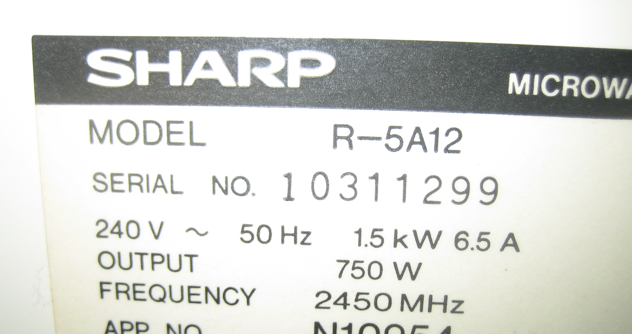
Questions 3-6 use the information contained on this Compliance Plate found on an old microwave.

3) The label lists the input voltage, power and current. Do they agree with each other?
(2 marks)
P = 1500 W P = V x I
V = 240 V 1500 = 240 x 6.5
I = 6.5 A 1500 ≠ 1560 (1 mark correct values, 1 for not exactly equal)

They don’t equal each other (though fluctuations in Voltage supplied and rounding to 2 sig figs, make it close enough in real life!)

4) Using the values given, calculate the resistance of microwave’s internal circuitry.
(2 marks)

V = 240 V V = I x R
I = 6.5 A R = V / I
R = ? R = 240/6.5
R = 36.9 Ω

5) Compare the input power to the output power. What is the efficiency and where does the lost energy go?
(2 marks)

P_{in} = 1500 W Efficiency = P_{out} / P_{in} x 100%
P_{out} = 750 W Efficiency = 750 / 1500 x 100%
Efficiency = 50%
50% of the energy is lost as other forms, sound, light, heat

6) How could you use a thermometer and one litre of water to determine the actual useful “output power” rating? No calculations are required.
(3 marks)

Take the temperature of water then place it into microwave for one minute and measure the final temperature (determine ΔT (1)). Calculate the heat energy (1) input Q=mcΔT over time (1)(Power).
Extra info:
P = Q/s = mcΔT/s = 1x4180 ΔT/60
for 750W the temperature should increase by ΔT = 750 x 60/4180 = 10.8ºC
7) A torch bulb has 2.35 Volts of potential difference applied across its contacts. What is the current flow if a charge of 16.8 Coulombs is moving across the bulb every minute?
(2 marks)
V = 2.35 V q = It
q = 16.8 C I = q/t
t = 60 s I = (16.8 x 60)
I = 0.280 A

8) Draw a diagram showing how you would connect a group of 4.00 Ω resistors (use as many as you need) to achieve an overall resistance of 5.00 Ω.
(2 marks)

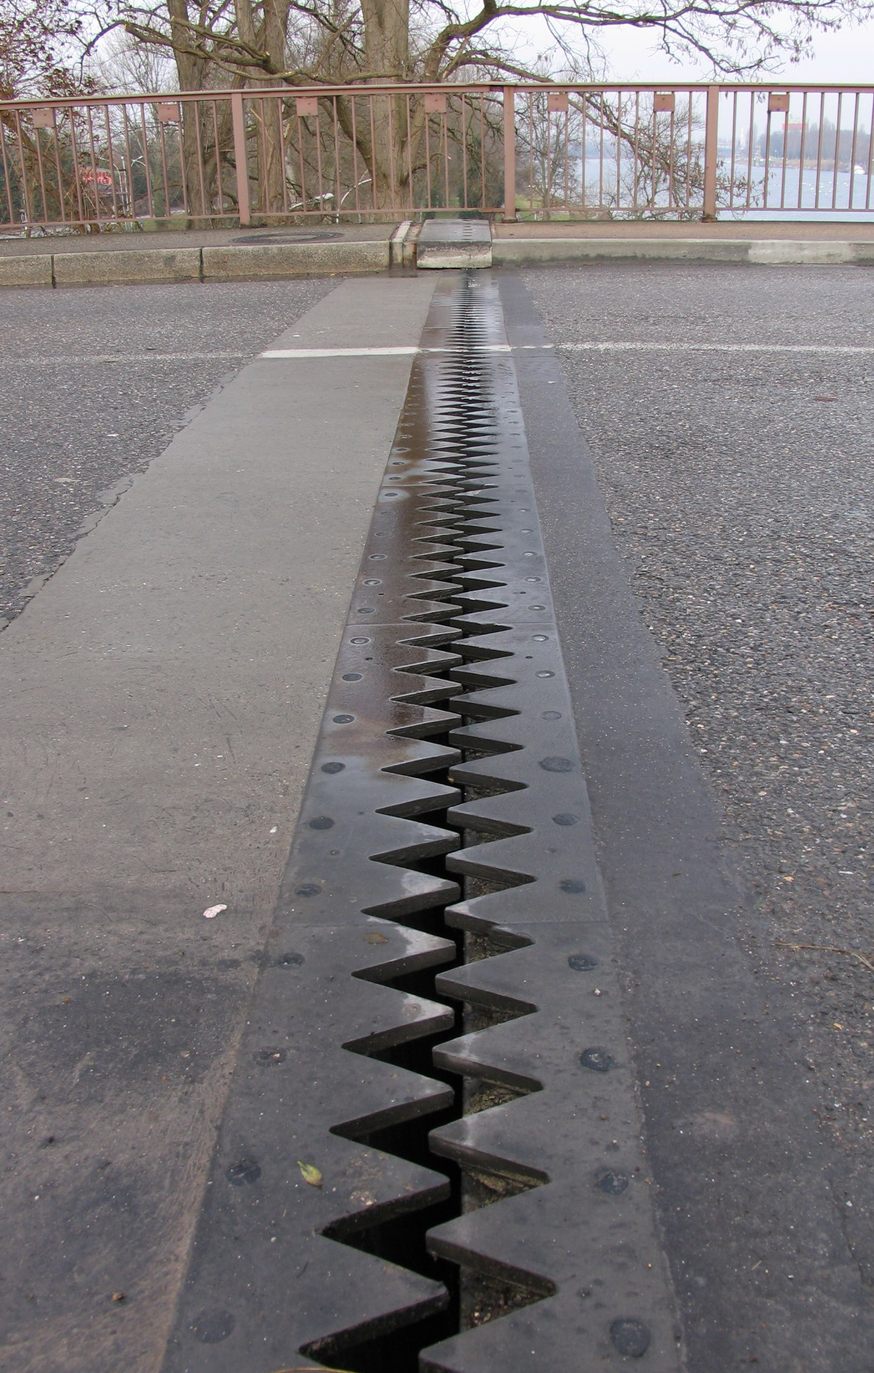
9) A picture of an expansion joint a road bridge is shown. Is this picture taken during a cold or warm day? Justify your answer using physics principles discussed in class.
(3 marks)

This picture is taken during winter, so it is cold (1). You can tell this from the joint being open (gap being wide) (1). When it is warmer, the kinetic energy of the particles (1) will increase causing the bridge to expand, closing the joint (lessening the gap).

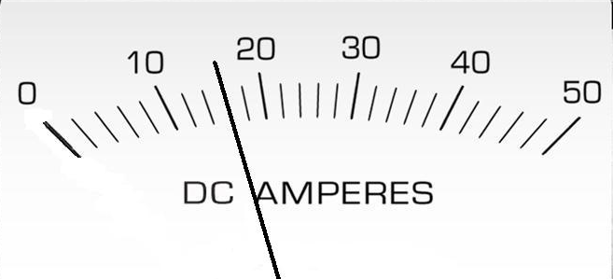
10) The meter to the left was used during an experiment.
(3 marks)
a) What does the meter measure?

DC Current

b) What is the value recorded on the meter?

16 (no decimal places)

c) What is the absolute error of the reading?

±1

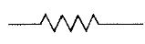
Questions 11 to 14 uses the following circuit diagram showing the connections of three similar resistors (labelled 1, 2 and 3).
C
E
F
G
A
B
D
2
1
3
(1 mark each)

11) The direction of conventional current flow is from

Circle the correct answer: G to A B to A D to A

12) To determine the potential difference across resistor 2, you would use the points

Circle the correct answer: A and C A and F B and C

13) There is no potential difference between the points

Circle the correct answer: A, D and G A, B and C E, F and G

14) Comparing the amount of current going through points A, D and G, the order from the greatest amount of current to the least is

Circle the correct answer: A, D then G G, A then D G, D then A

15) A kettle is brought to the boil from 25.0ºC and left boiling for 3.50 minutes. Half of the 1.250 litres of water boils away in that time leaving 0.625 litres boiling. How much energy has been converted?
(3 marks)
Q_{Total} = Q_{heating} + Q_{Vaporisation} Q = m_{water}cΔT + m L_{v}
m_{water}?= 1.25 kg Q = 1.25x 4180 x 75 + 0.625 x 2.25 x 10⁶
m_{g} = 0.625 kg Q = 3.92 x 10⁵ + 1.41 x 10⁶
L_{v} = 2.25 x 10⁶ Jkg⁻¹ Q = 1.80 x 10⁶ J

16) A 75.0 W / 240 V light globe is left on for 10.0 hours, how much energy does it convert?
(3 marks)

P = 75.0 W W = E = VIt
t = 10 x 60 x 60 P = VI
t = 36000 E = Pt
V = 240 V E = 75.0 x 36000
E = 2.70 x 10⁶ J

17) A 21.7 g block of aluminium, which is initially at a temperature of 17.5 °C, is added to a 55.5 g copper calorimeter containing 153 mL of water at 60.0 °C. What is the final temperature of the aluminium block after the system has achieved thermal equilibrium? Assume no energy is lost.
(3 marks)

Q_{gained} = Q_{lost}
Q_{Al} = Q_{Cu} + Q_{Water}
mc(T_{f} - T_{i}) = mc(T_{i} – T_{f}) + mc(T_{i} – T_{f})
0.0217x900(T_{f} – 17.5 ) = 0.0555x390x(60.0 – T_{f}) + 0.153x4180x(60.0– T_{f})
19.53T_{f} – 341.7751298 =.7 - 21.645 T_{f} + 38372.4 – 639.54 T_{f}
680.715T_{f} = 40012.875
T_{f} = 58.8 °C

18) The Synergy power company of Western Australia charges energy (joules) in kWhr (kiloWatthour). Show using appropriate formulae/working how many joules of energy are in one kWhr.
(2 marks)
1kW = 1000W = 1000J per second
1 hour = 60x60 seconds
E=Pt
E =1kWxhr = 1000 Js⁻¹ x 60 x 60 s= 3600000J

Section two: Problem-solving 60 marks

This section has six (6) questions. Answer in the spaces provided.

Suggested working time: 75 minutes

1) Two metal spheres, one of -5.00μC charge the other of +9.00μC charge, are placed 0.500 m apart from centre to centre. Where μ (micro) = 10⁻⁶.
[7 Marks Total]
a) Calculate the force acting between the charges.
(2 marks)
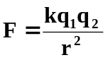
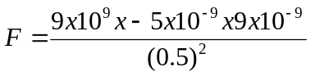
F = 1.62 x 10⁻⁶ N

b) The two spheres are brought together in contact with each other and moved apart to 0.250 m.
i) Explain what happens to the charges.
(2 marks)
Like charges repel and are trying to move apart, but are drawn to the opposite charge and move towards them. As the two spheres come into contact, the charges (electrons) quickly move across the two spheres until equally spaced and evenly distributed. Any left over charge is evenly distributed between the two spheres (-5 + 9 = 4 C left; 2 C each)

ii) Calculate the new charges of the spheres, placing the values in the correct places. Then draw the electric field lines, showing direction and interaction after the contact.
(2 marks)

_+2 μC
_+2 μC

c) How does the force in situation (b) compare to the force calculated in (a)?
(1 mark)

Circle the correct answer: GREATER EQUAL SMALLER
2) The graph below shows the change in temperature while heating a 20.0 g sample of an unknown solid. The total energy absorbed by the sample for each stage, A-E, is given below:
[9 marks total]
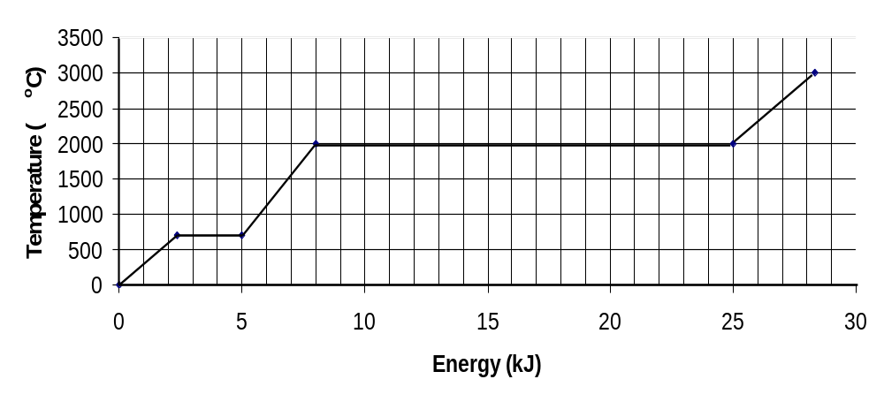

E
D

C

B
A

a) Which of the section(s) has the unknown material as a:
(3 marks)
i) Solid ________A

ii) Gas ________E

iii) Melting ________B

b) Calculate the latent heat of vaporisation for this unknown material.
(3 marks)
Q = 25000-8000 = 17000J
Q = mL_{f}
L_{f} = Q / m
L_{f} = 17000 / 0.020 (1 correct value; 1 formula/rearrangement and numbers in)
L_{f} = 8.5 x 10⁵ J Kg⁻¹(1 answer)

c) Calculate the specific heat capacity of this material in the liquid phase.
(3 marks)

Q = 8000-5000 J Q = mcΔT
m = 0.020 kg c = Q / MΔt (1 correct values)
c = ? c = 3000 / 0.020 x 1300 (1 rearrangement and numbers in)
ΔT = 2000-700 ºC c =115 J Kg⁻¹ K⁻¹ (1 answer)

3) The following circuit is made with the resistors as shown. [9 Marks Total]

A

2Ω
7Ω

11Ω
5Ω

B

9Ω
4Ω

a) What is the effective resistance from Point A to Point B?
(2 marks)

R_{T} = 2 + ((7+5)⁻¹ + (11+9)⁻¹)⁻¹ + 4
R_{T} = 2 + 7.5 + 4
R_{T} = 13.5Ω

b) If a potential difference of 24 volts is applied across this circuit from A to B, what current would flow?
(2 marks)
V=IR
I=V/R
I=24/13.5
I= 1.78A

c) What would the current flow be through the 9Ω resistor with the 24 volts applied?
(3 marks)

V=IR
V=1.78*7.5
V= 13.3 V across 11 Ω and 9 Ω
I=V/R
I=13.3/20
I= 0.667 A

d) Using the resistors above, explain how you would rearrange the resistors above to create new circuits with the maximum and minimum resistance possible. (No calculation required)
(2 marks)
A maximum resistance circuit would have all of the resistors in series.
A minimum resistance circuit would have all of the resistors in parallel.

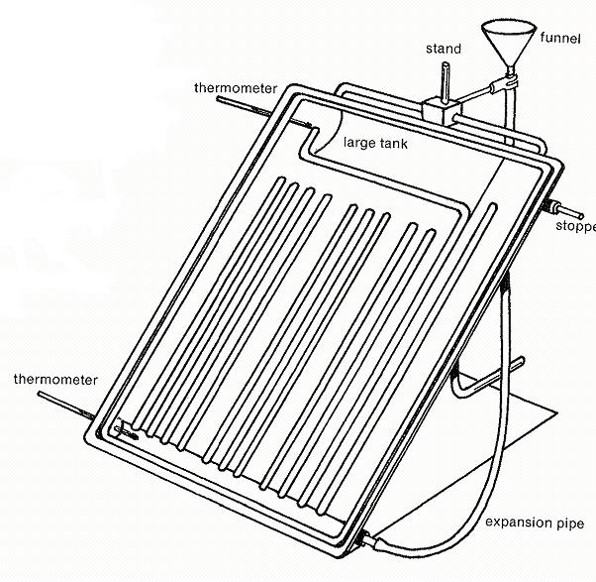
4) A student has set up an experiment designed on building a passive solar hot water heater. She designs the apparatus as shown, places it in a sunny area and records the temperatures. After an hour, the temperatures are recorded again. The thermometers are digital, with readings in whole numbers only (no decimals). The table has begun to be filled in.

[16 Marks total]

a) Complete the table.
(2 marks)

 | Initial  Temperature | Final  Temperature | Temperature Difference | Absolute uncertainty
Top | 20 ºC | 75 ºC | 55 ºC | ±1 ºC
Bottom | 20 ºC | 31 ºC | 11 ºC | ±1 ºC

b) Explain why the water is warmer at the top of the apparatus, than at the bottom, at the end of the experiment. (Include Kinetic Theory for more marks)
(3 marks)

This is due to convection (1) were warmer water rises and colder sinks setting up a current (1). Warmer water becomes less dense as it increases in temperature and its kinetic energy per molecule increases, expanding the liquid (1).

c) The student has chosen to paint the apparatus black, explain why she has made this choice.
(2 marks)

Radiation (1) is the main form heat input. Black has a high level of emissivity compared to other colours (absorbs the suns radiation well) (1).

d) What is one source of uncertainty that might occur when trying to repeat the same experiment to get the same results and what effect would it have?
(2 marks)

Such things as, same angle to sun, same time of day, cloudiness, external temperature, etc; effect would be to not warm up as much, limit heat transfer, etc.
e) Over the next few days, the student completed the experiment four more times. The results are shown on the table. Graph the results below.
Experiment | 1 | 2 | 3 | 4 | 5
Time (minutes) | 60 | 20 | 40 | 10 | 80
Temperature Change (ºC) | 55 | 20 | 35 | 12 | 65

(4 marks)

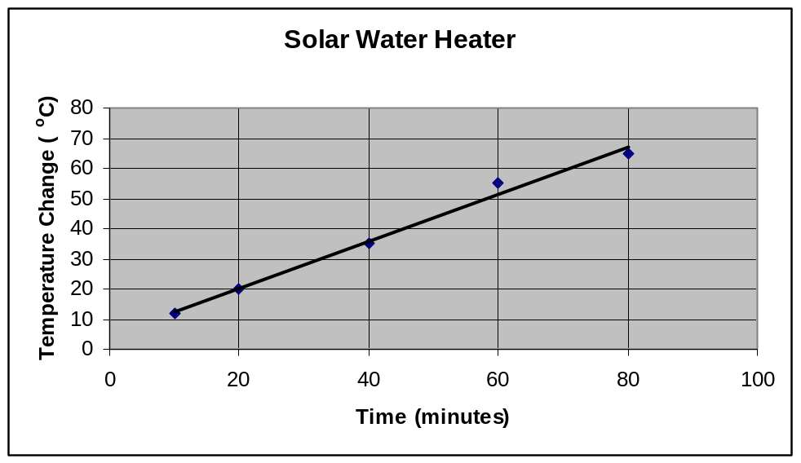
Title/Labels(1)
Units (1)
Data in Time sequence (1)
Line graph (not Bar) with line of best fit(1)

f) What conclusion can be drawn about the relationship in the graph above?
(1 mark)
As the length of time increases the temperature increases proportionately.

g) If the initial temperature of the water was 17ºC, what would you expect the final temperature of the water to be after 50 minutes?
(2 marks)
T_{f} = T_{i} + ΔT ΔT=43 - 47 ºC
T_{f} = 17 + 45
T_{f} = 62ºC (60-64ºC for range of acceptable answers)
5) A year 12 Physics student is trying to find a quiet place to study, so moves into a shed in the back yard. He doesn’t want to do without modern conveniences so gets a long extension cord from his parents’ place to the shed. He uses a power board to plug in all the appliances. The shed now has 240V supplied to:
  - 60W light bulb in a lamp
  - 1000W bar heater
  - 750W microwave [10 Marks Total]

a) The power board has a fuse rated at 10A, does it trip if all of the appliances are turned on?
(3 marks)

P = 60 + 1000 + 750 P = VI
P = 1810W I = P/V
V = 240V I = 1810/240
I = ? I = 7.54 A, No, the power board is OK

b) Calculate the resistance of the 750W microwave.
(3 marks)
P = 750W P=VI V=IR
V = 240V I = V/R
R = ? P = V²/R
R = V²/P
R = 240²/750
R = 76.8 Ω

c) When all the devices are operating, how does the total resistance of the circuit compare to that of just the microwave? (No calculations required)
(1 mark)

Circle the correct answer: GREATER EQUAL SMALLER

d) The element of the heater is a non - Ohmic conductor. Just after it is turned on it begins to increase in temperature and the current drawn changes. Use the Kinetic Theory to explain what happens to the current (and therefore resistance) as the element warms up to operating temperature.
(3 marks)
The current draw decreases (1)
The kinetic theory explains that as the temperature increases, the kinetic energy (motion) increases (1)
Electrons find it more difficult to move through the increasingly energetic particles, ie the resistance increases (1)

6) Lightning bolts regularly hit tall buildings as shown on the picture to the right, taken on 18 Nov 2001 by Frank Bilki for the West Australian Newspaper of the BankWest tower being hit with lightning. In order to limit the damage to the surroundings, a lightning rod is used.
[9 marks total]

a) Explain what properties a lightning rod has and how it would limit damage.
(2 marks)
The lightning rod would have very low resistance (good conductor), able to carry a large current in a short period of time.
This would protect the building, by providing path for the charge to dissipate, the keeping the current from travelling through other areas causing damage.

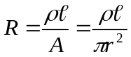
b) Manufacturers of lightning rods use this formula to calculate the thickness of rod required.

A 214m length (l) of copper rod is needed to create a lightning rod for the BankWest tower. If the minimum resistance needed for a lightning rod is 7.50 x 10⁻³ Ohms (R) and given that the resistivity (ρ) of copper is 1.70 x 10⁻⁸ Ohm metre. Rearrange the above formula and determine the radius of the copper wire required.
(3 marks)
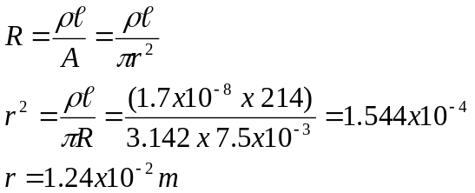

c) After this particular strike using a lightning rod with 7.50 x 10⁻³ Ohms, the recording device is found to be faulty. The record only has the potential difference of 1.5 x 10⁶ Volts and a flow of 1.00 x 10³ Coulombs of charge. Calculate how long the current flow lasted?
(4 marks)
V = 1.5 x 10⁶ V V = IR
q = 1.00 x 10³ C I = q / t
R = 7.50 x 10⁻³ V = (q / t) R
I =V/R t = q R / V (2 for the formula derivation/substitution)
t = ? t = 1.00 x 10³ x 7.50 x 10⁻³/ 1.5 x 10⁶
t = 5.00 x 10⁻⁶ s

Section three: Comprehension 18 marks

This section has one (1) question. Answer in the spaces provided.

Suggested working time: 25 minutes

Adapted from http://en.wikipedia.org/wiki/Perm_(hairstyle)

Historically, women have wished to have wavy or curly hair which seemed more attractive than the more common straight hair. Attempts to curl it by wetting and winding or tying with paper produces only superficial effects. Washing would immediately destroy the waving. High temperatures were known to be effective for waving hair but impractical unless applied to hair separated from the scalp, which is how wigs were made. An early system consisted of a system of winding and holding the hair on a former which was then inserted each time into the electric heater.
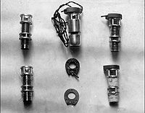
First permanent-waving heaters designed by Calvete in 1917

A wireless permanent-waving machine introduced in 1934 by Icall Limited to satisfy a demand for a machine in which there was no direct connection to electricity when the heaters were applied. Because such heaters started cooling as soon as they were applied to the hair, they were bulkier so as to provide a greater heat sink. Even so, timing had to be longer because of the cooling of the heater and waves tended to be softer.
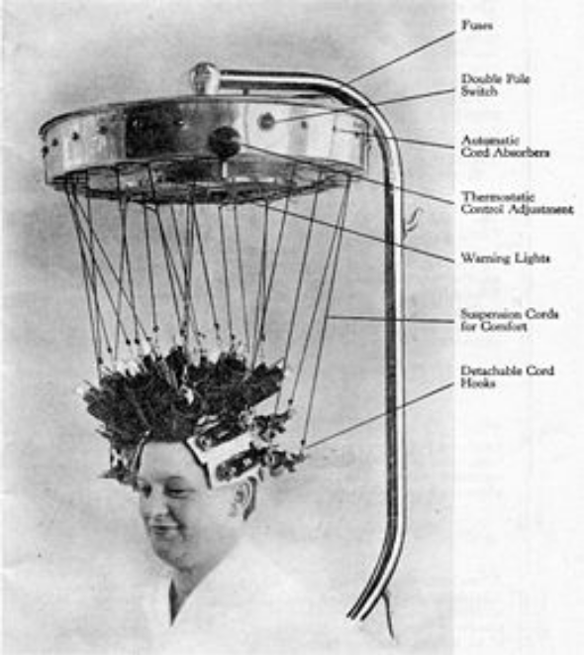A Wireless Permanent-Waving Machine designed by Icall in 1934, in which the heaters were disconnected before applying to the head, known as the "falling-heat" method. The heaters were bulkier so as to store more heat, since they began to cool as soon as applied. The heat was controlled according to the type of hair by a thermostat control.

Icall also pioneered the use of plastics in hairdressing equipment, specifically a thermosetting plastic, Bakelite which was used not only because of its electrical properties in the windings of motors and heaters, but in the outer coverings of the heaters. They were less affected by corrosion and were less likely to burn the fingers of the hairdresser. Icall also used Bakelite for the outer casings of hand-held hair-dryers and also for the large linings of pedestal hair-dryers.

It can be imagined that at a time when electrical installations were not to today's standards and at one time were not even earthed, the application of electrical windings to wet hair resulted in enough accidents to worry women. Icall developed what was called the 'wireless' system, in which the electric lead to the heater was replaced by a cord which took the weight of the heater, and the heater was heated by plugging into a socket in the chandelier. Outwardly, the machine looked similar to the earlier model, but at no time was there an electric potential near the head.
Questions

a) Describe what is meant by a “heat sink” for the bulkier heaters that were attached to the hair. (2 marks)

A larger mass (1) means that more heat energy can be stored (1) and then released into the hair

b) The first synthetic plastic Bakelite was used extensively for heating and electrical applications. Explain a property of Bakelite that would have

i) kept hairdressers from burning their fingers.
(2 marks)

Bakelite would be a poor conductor (1) of heat, transfering only a little heat energy into the hairdresser’s fingers (1), changing the fingers temperature very little.

ii) prevented the hairdresser from getting a shock when disconnsecting the heaters.
(2 marks)

Bakelite is a poor conductor (1) of current (carrier of charge) so there would be little chance of a flow of charge (1) being carried through to the hairdresser.

c) Describe the danger to women having their wet hair curled that the wireless system was addressing.
(3 marks)

Wet hair provides less resistance to electric current than dry hair or skin. (1)
A current carrying electric heater in wet hair runs the risk of current leakage into the woman. (1)
The sitting woman could have the current short through them into the ground. (1)

d) There are 16 hair rolling formers and heaters attached in the chandelier for heating. Would you expect the formers to be connected in series or in parallel? Justify your answer.
(1 mark)
Series: cheaper to manufacture, easier to wire; or,
Parallel: independent circuit, each works without the others in, keeps former hotter longer.

e) Draw a circuit diagram showing how three (3) of the formers would be connected to the power supply below. Include a switch and a fuse in your circuit to protect your formers.
(2 marks)

Power Supply
Active

Neutral

Answer depends on above (series or parallel), though must have fuse then switch from active wire to formers for full marks

f) Each of the 16 former and heater combinations were made of brass with a mass of 235 grams with equal resistances. If an Australian version took 6.50 minutes to heat all the formers to a working temperature of 88.7 ºC from 23.5 ºC, what was the resistance in the circuit?
(6 marks)
m = 22 x 0.235 Q_{required} = mc(T_{f}-T_{i})
c = 370 J kg⁻¹ K⁻¹ =22 x 0.235 x 370 x (88.7 - 23.5)
T_{f} = 88.7 ºC = 124721 J (2 marks)
T_{i} = 23.5 ºC

t = 6.5 x 60 P = Q/t
P = ? P = 124721 / (6.5 x 60)
P = 320 W (1 mark)

V = 240 V I = P/V = 320 / 240
I = I = 1.33 A (1 mark)

V = IR
R_{t} = V/I = 240 / 1.33
R_{t} = 180.45 Ω (1 mark)

Series
R_{t} = 16 x R_{f} R_{t} = 180.45 / 16
R_{f} = R_{t}/16 R_{f} = 11.3 Ω
(1 mark for either, depending on (d))
Parallel
R_{t} = (16 x R_{f}⁻¹)⁻¹ R_{t} = 180.45 x 16
R_{f} = R_{t}x16 R_{f} = 2.89 x 10³ Ω

END OF EXAM
This blank page has been provided for additional workings

This blank page has been provided for additional workings

